Jocelyn Perez

Professor Walters

CSC 4500

14 November 2021

Assignment 6

1. 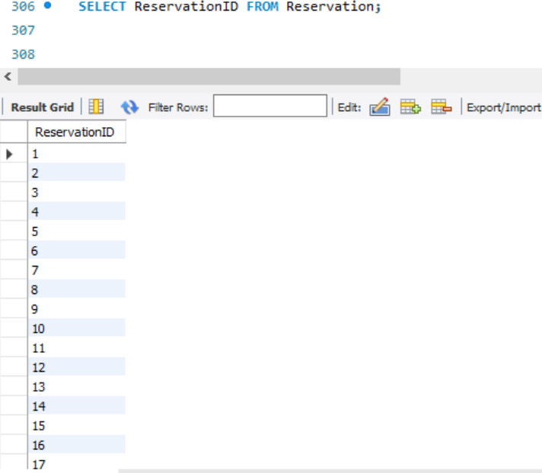

We want to see all the ResevationID’s from the Reservation table.

1. We want to see everything in about the Movies.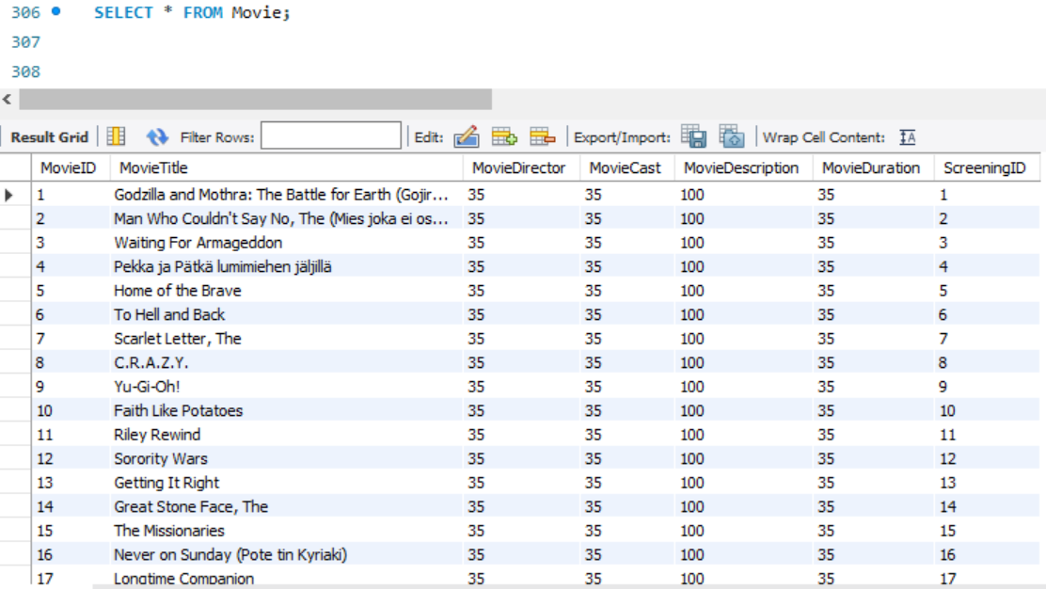
2. We want to see everything about the Auditorium information

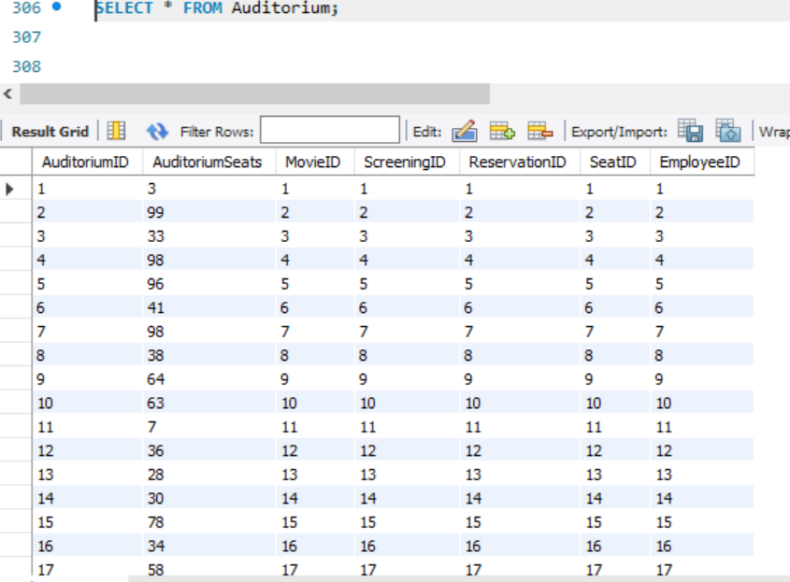

1. We want to know all the movie titles playing.

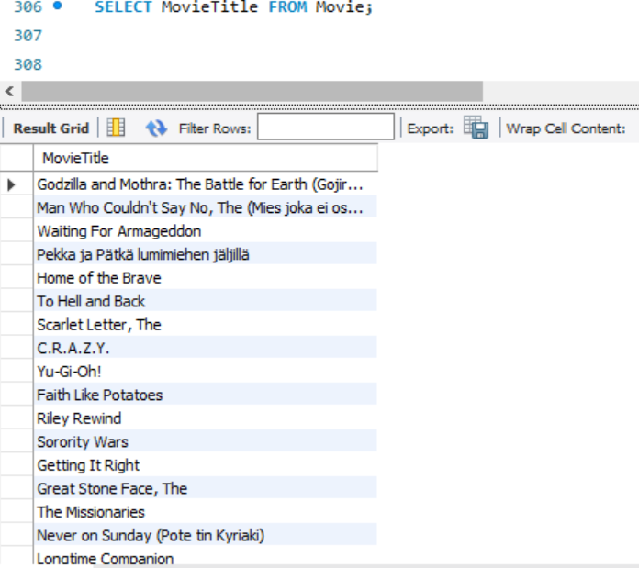

1. We want to know all the movie information from screening less than 1.

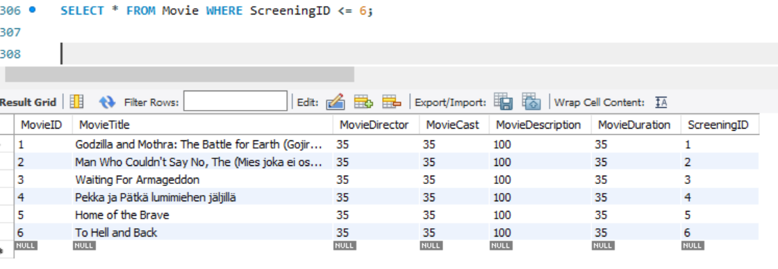

1. We want to know all the customers first name that has a B somewhere in their name.

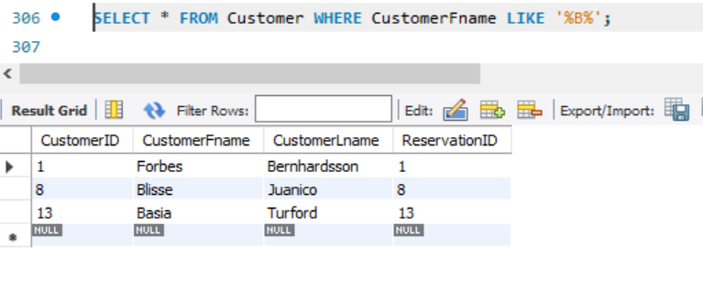

1. We want to know all the movies titles that have a T in them somewhere.

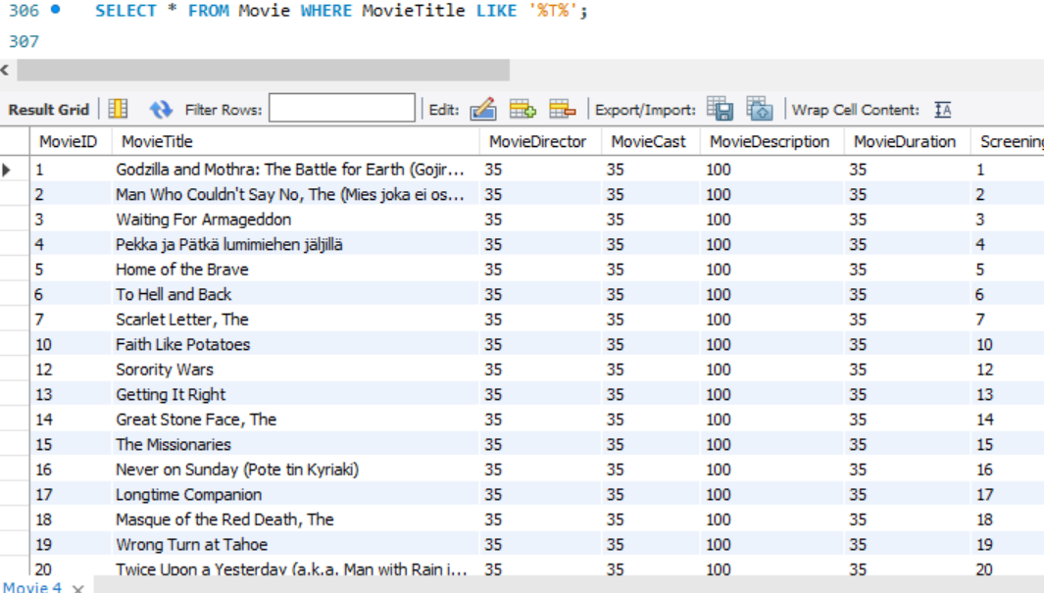

1. We want to know all the Screening information grouped by movieID

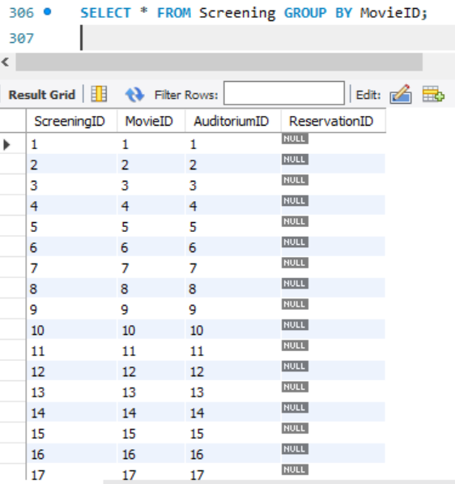

1. We want to know all the seat numbers between 20 and 50.

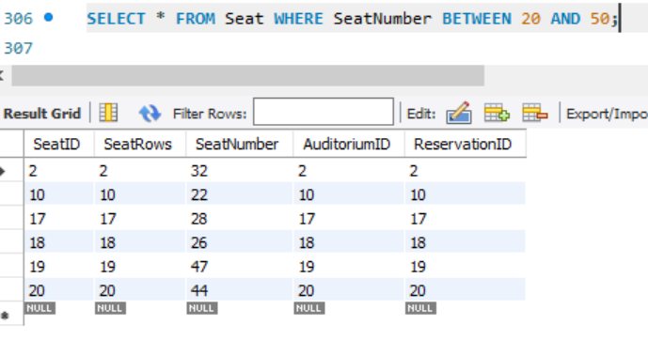

1. We want to know if the reservation has been paid by the customer.

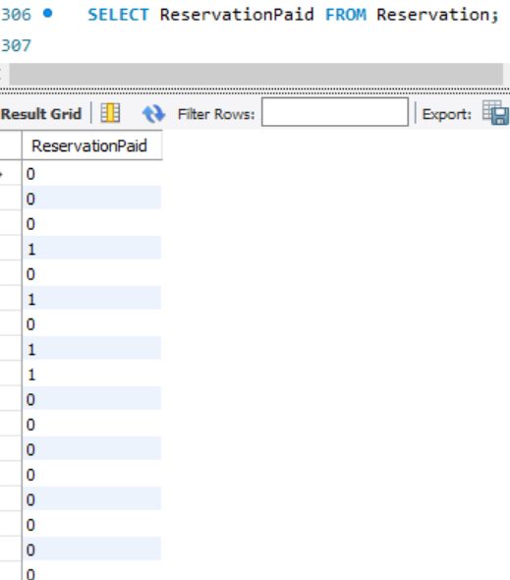

1. We want to know the who has purchased a ticket to what movie.

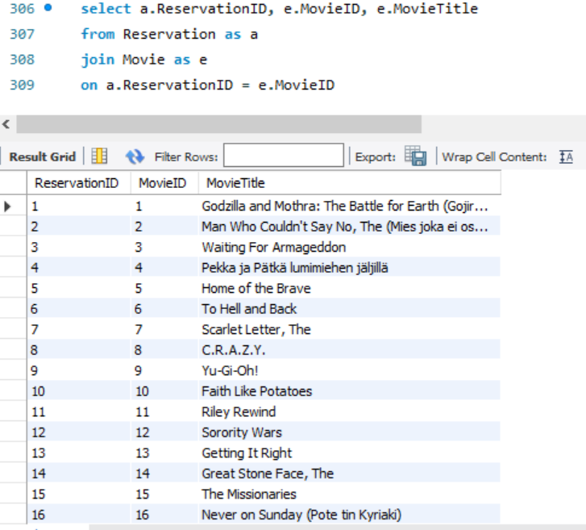

1. We want to know which screening room will play what movie.

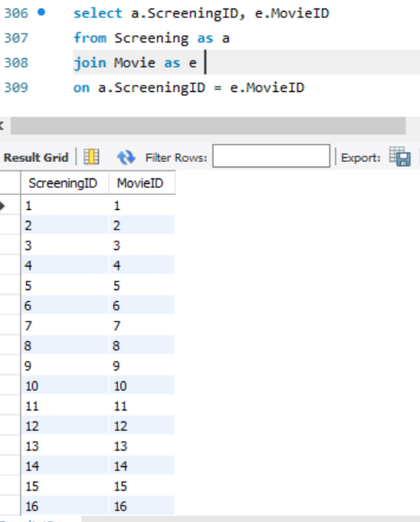

1. We want to know which employee’s are in which auditorium.

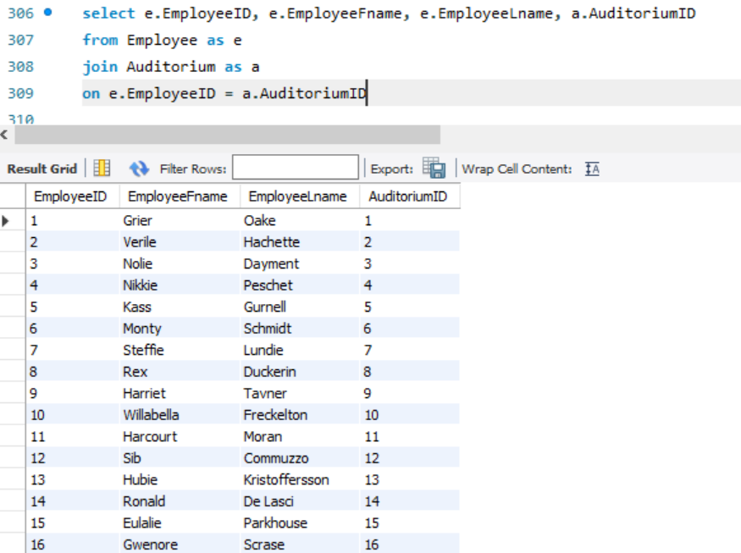

1. We want to know which movie is playing in which auditorium.

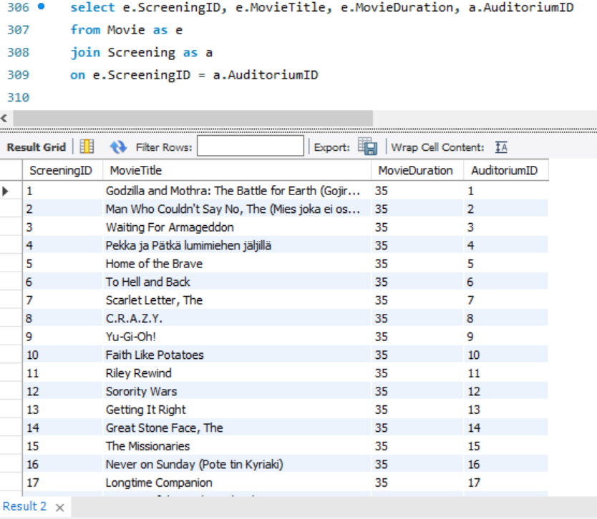

1. We want to know which customer is in which screening for their movie.

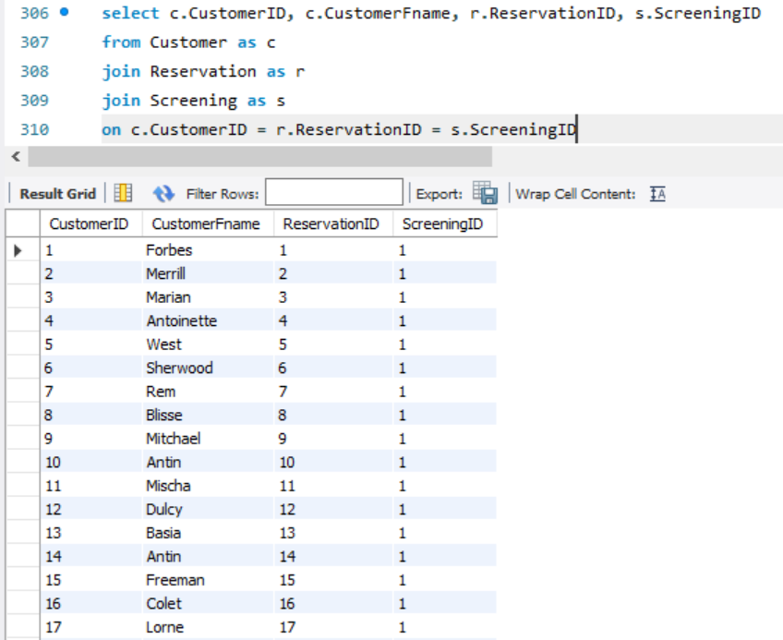

1. We want to know the order by seat numbers.

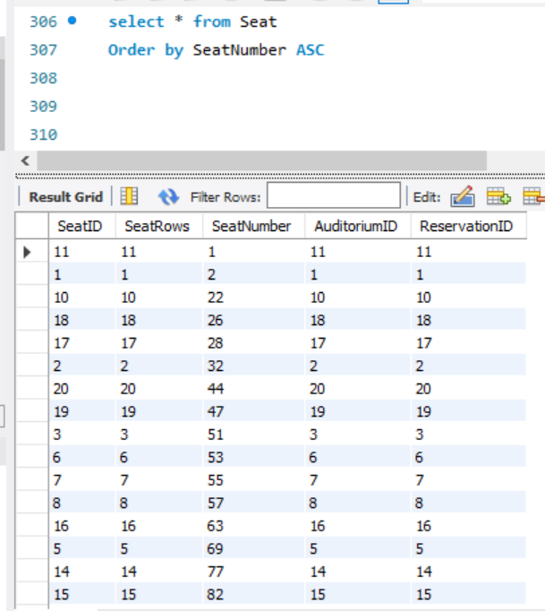

1. We want to know the seat rows less than or equal to 25 by group of seat number.

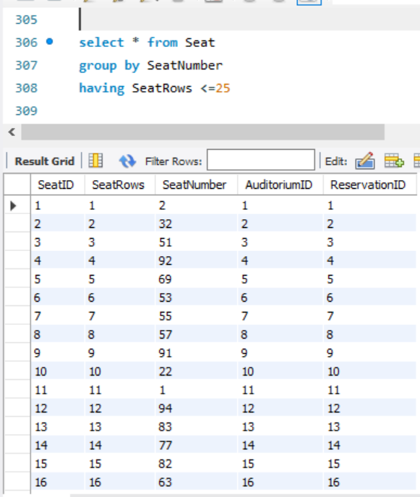

1. We want all the auditorium seats greater than or equal to 50 to be removed and only see the remaining.

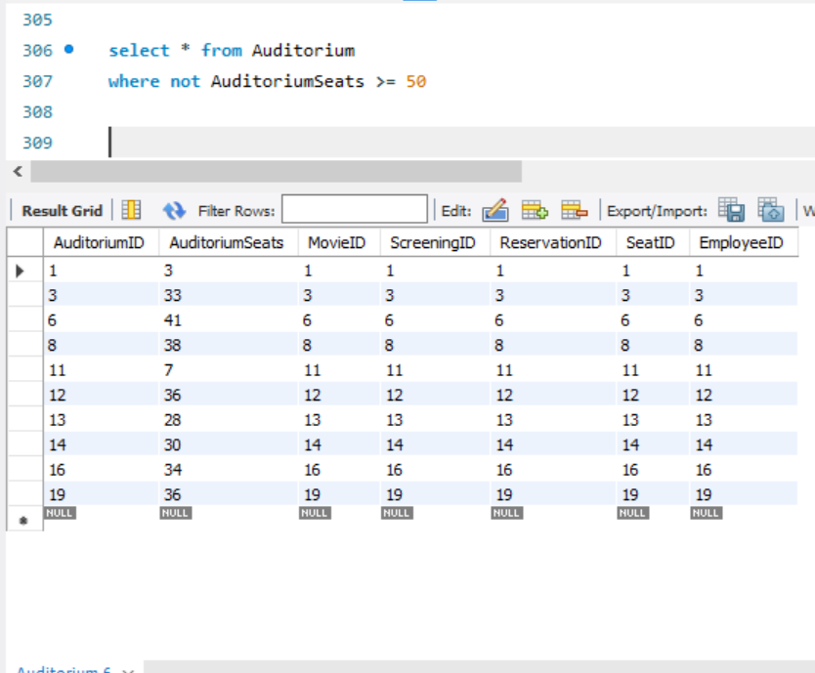

1. We want to see all the employee information.

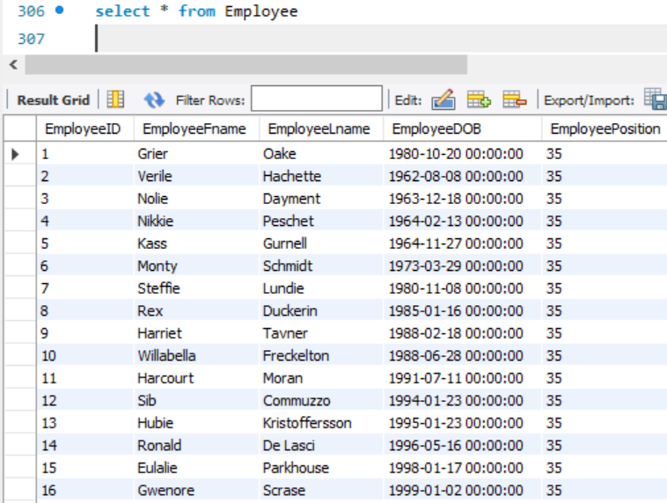

1. We want to see all the information in seat reservation.

